Handson2
Task 1: Flexbox Navigation & Header Layout

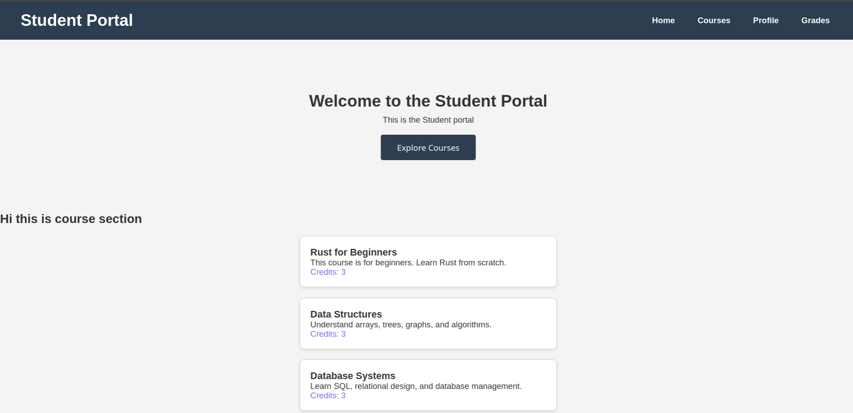
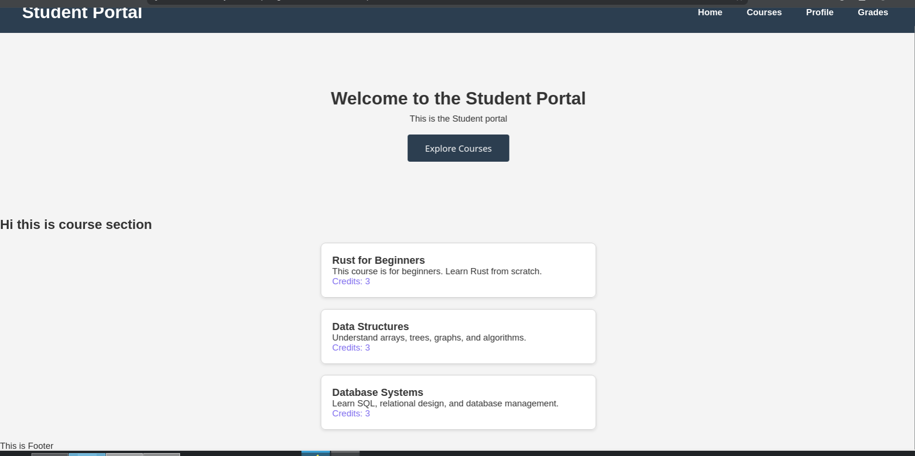

Task 2: CSS Grid Course Card Layout

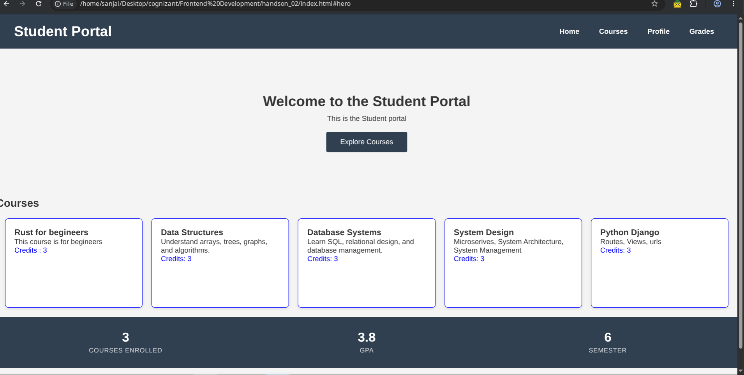
Task 3: Responsive Design with Media Queries
24. Rewrite your existing CSS to be mobile-first: start with a single-column layout as the default (no media queries), then use min-width media queries to enhance larger screens
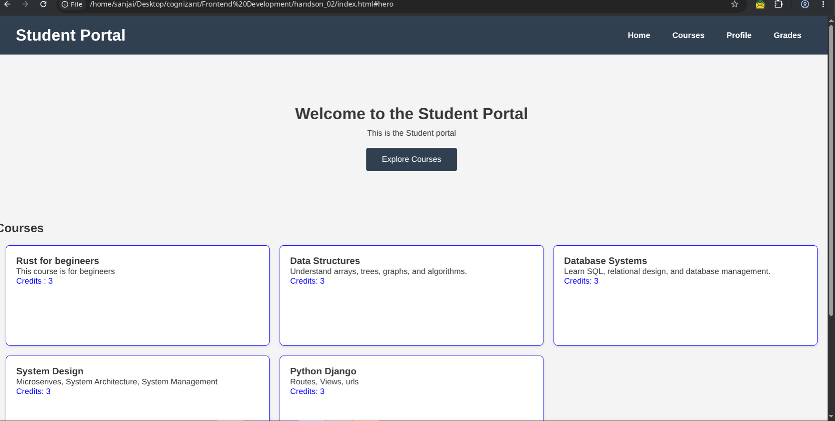

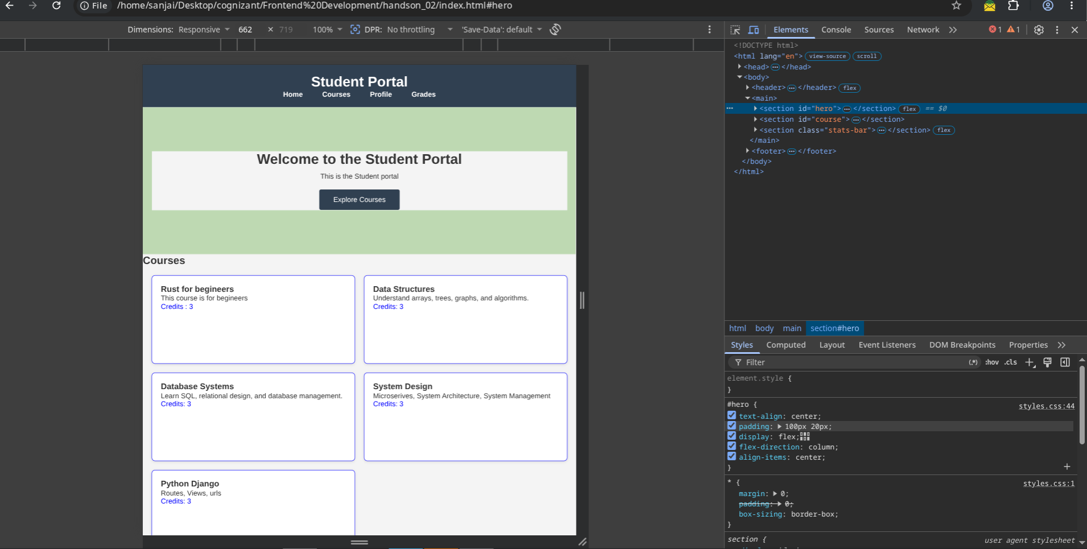
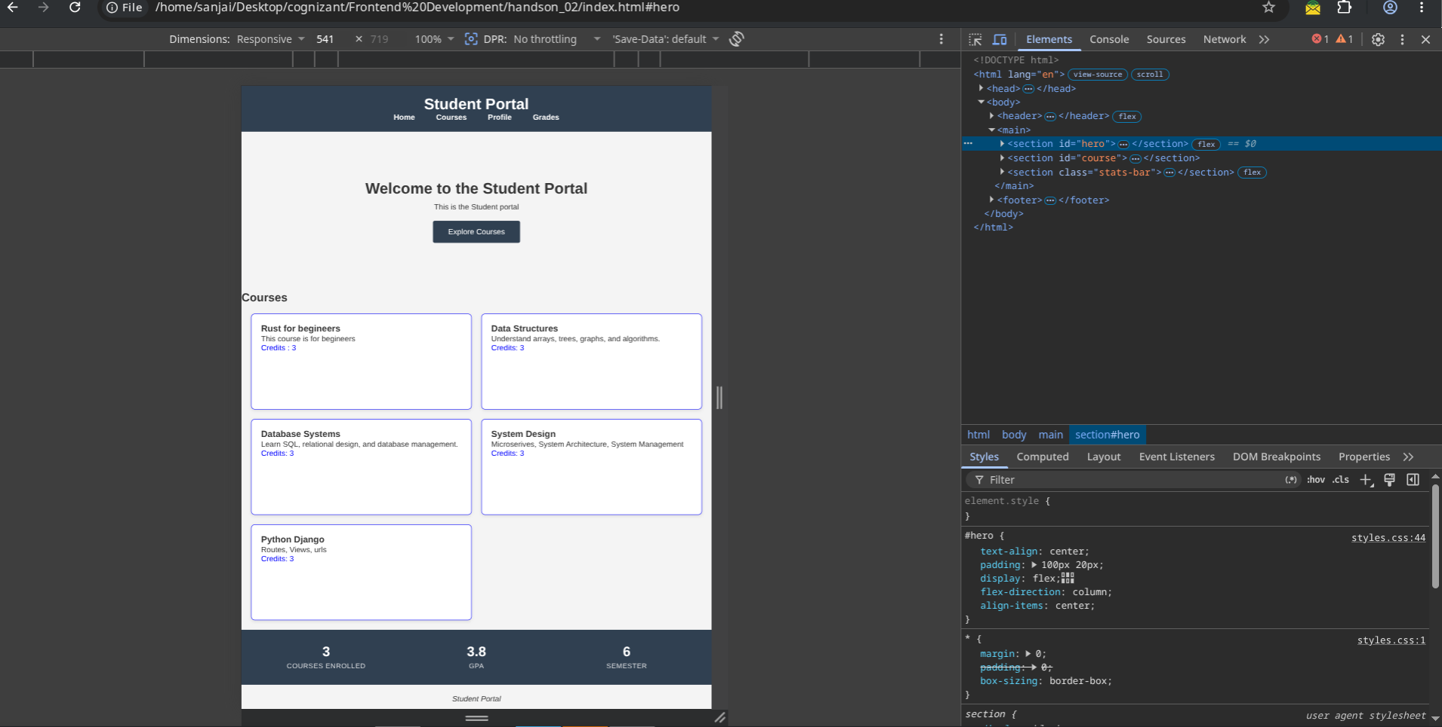

25. Add a media query at min-width: 768px: change the course grid to 2 columns and show the full navbar (replace a hamburger placeholder text with the actual nav links).
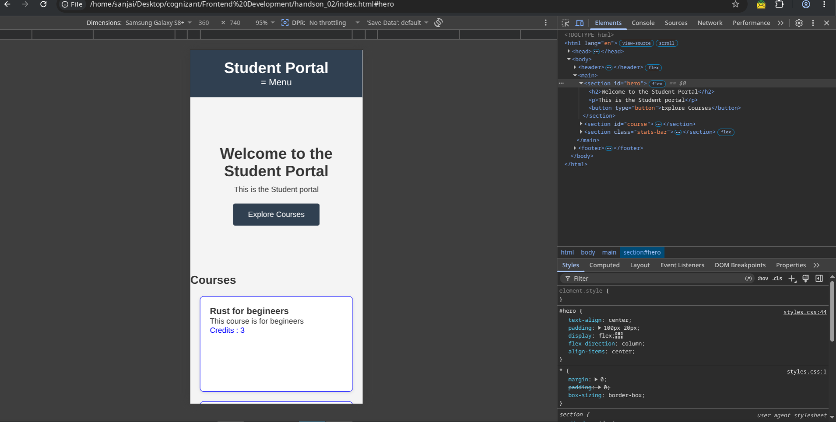
26. Add a media query at min-width: 1024px: change the course grid to 3 columns and increase hero section padding
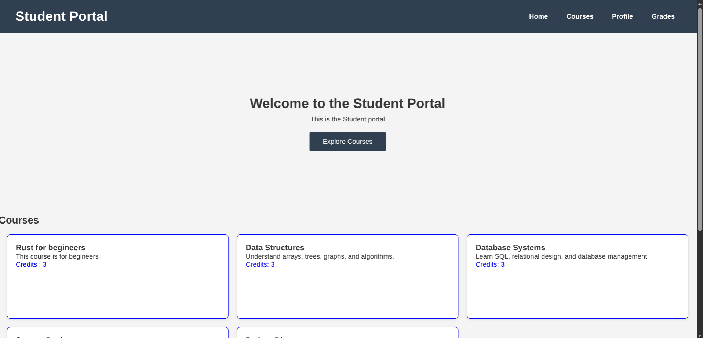

27. Use viewport units: set the hero section min-height: 40vh and the site title font-size to clamp(1.5rem,3vw, 2.5rem) for fluid typography.
